


Solution Proposal Report
Sharjah Municipality
Development of the Automated Fire Extinguisher System
EGN 4823 - Industrial Problem Solving
Engineering Department “Electronics “
Sharjah Women's College

For: Dr. Gebriel Gannat
Done by:
Amina Abdallah - H00257726
Sara Saif - H00272529
Shaikha Ahmed - H00272785
CRN: 23887
Submission Date: Wednesday - Mar 22nd, 2017

Table of Contents

1- Introduction: 3
2- Background: 5
3- Proposals description: 7
3.1- Solution one: 7
(Cutting off the electricity from the whole room by using a contactor) Error! Bookmark not defined.
Cost analysis: 10
Time analysis: 10
Advantages: 11
Disadvantages: 11
3.2- Solution Two 12
(Cutting off the electricity from the door only by using a relay) Error! Bookmark not defined.
Cost analysis: 14
Time analysis: 14
Advantages: 15
Disadvantages: 15
3.3- Solution three: 15
(Cutting off the electricity from the door only by changing the software manually) Error! Bookmark not defined.
Cost analysis: 17
Advantages: 17
Disadvantages: 17
4- Selecting final solution: 18
5- Time-based plan for researching problem solutions: 20
7- Conclusion: 22
8- References: 23
9- Appendix 1: 24
10- Appendix 2: 25

1- Introduction:

As explained in detailed in the previous report which is (Problem Description Report), Sharjah Municipality (SM) department has a serious problem in the data center room that includes all the necessary data of the organization. Briefly, the problem is that the automated fire extinguisher system in this room is a very simple system that does not consider the safety issue. Although it works without any defect but it does not connect to any advance system that can ensure more safety like; cutting off the electricity at the moment of detection the occurrence of any fire, sending an SMS to the firefighting department or any responsible in SM, or even detecting the presence of any person in the room.
Different solutions has been discussed in different sources, there is a project that published in Circuit Digest website, called Automatic Staircase Lights using PIR Sensor and Relay. The project proposed two years ago by Jayant. The idea of the project is to control the lights on the staircase, that it will switch ON if someone on the stair; otherwise the lights will switch OFF automatically. Passive Infrared Sensor (PIR) and Relay are the main two components in this circuit. The PIR is a sensor that used to detect the movement of the human body, and the Relay is an electromagnetic switch that used to switch ON or OFF the lights on the staircase [1].
From other source, which is Edgefx Kits there is a project that published by Amit Parashar on 7th June 2016. The idea of the project is to cutoff the load when the input voltage is above or below a set value. The main components that were used are; two 555 timers are used as a comparator and a relay to cutoff the load. This project does not need any software programming. The future modification that will be added is sending a SMS by using GSM modem and installing an alarm to alert the users when voltage fluctuation happens [2].

In this report three solutions will be discussed;
1- Cutting off the electricity from the whole room by using a contactor.
2- Cutting off the electricity from the door only by using a relay.
3- Cutting off the electricity from the door only by changing the software manually.

This report will be organized as follow;
- Introduction
- Background
- Proposals description
- Selecting final solution
- Planning for implementation of the solution
- Conclusion
- References
- Appendix

2- Background:

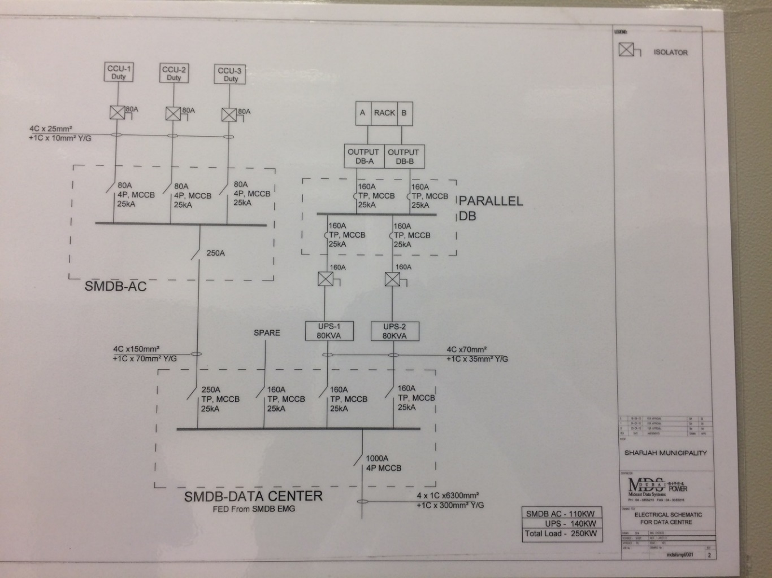
The electricity of the data center room comes from Sharjah Electricity and Water Authority (SEWA). This electricity is separated from the whole building, it comes with 1000A by three phases. The distribution of the electricity of the room is shown in figure 1 and for a clearer picture (please see appendix 1). As you can see that the phases are distributed into two phases that go to computers (Racks) with 160A for each phase, and three phases go to the ACs with 80A. There are two parallel uninterruptible power supply (UPS) batteries to generate the electricity automatically in case of shutting off the electricity for any reason to protect the racks from any damage or loss of data.
Fig.1 Distribution of the electricity in the server room

Regarding the circuit breaker that they use which is Molded Case Circuit Breaker (MCCB) briefly, it is an electrical protection device. This type of circuit breaker can be used in wide range of current ratings that vary from low values like 15 amperes to huge values like 2500 amperes. There are three main functions of MCCB which are; protection against overload, protection against electrical faults and switching a circuit on and off [3].

Where that the data center room in Sharjah municipality is a very sensitive room, they had installed an electromagnetic lock on the door that is controlled by a software called (Keyscan Access Control System). The data center room consists of two rooms, the first room is the server room which includes the racks, and next to the server there is another room that contains this software that installed in one of the computers. The separation between these two rooms is glass only. Therefore, if anyone in one of these rooms will be able to see the other person in the next room. The security door in the data center room has a separate control unit (CU), and there is a pushbutton that connects to this CU. There is an electromagnetic lock on their security door that it is automatically locked the door unless someone pressed the pushbutton that will lead to disconnect the electricity on the magnetic locked and the door will be opened.

3- Proposals description:

3.1- Solution one:

Since the main supply of the server room consists of three phases that come from SEWA with high amperes so for these reasons a contactor will be a way to control and cut off the circuit of the electricity instead of using a relay only.
The contactor is an electromagnetic switch and it is a special type of relay, the difference is that contactor works in either one phase, two phases or even three phases and it can control heavy loads such as motor and generator. There are different kinds of contactor relating to the capacities and the features. It consists of two main parts, the contacts and the coil, normally contractors have two contacts which are; Normally Open (NO) and Normally Closed (NC) [4].
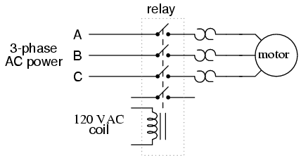
The operating principle of the contactor is demonstrated in figure 2. In order to energize the magnetic coil there must be a main source that connected to it, 120 volts AC is needed to connect with the contacts and it considers as a standard power. Related to the figure below if the coil energizes, the contact will move towards the coil so it will be closed then the current will flow to the load which is the motor in this case.
Fig.2 Contactor schematic diagram

The same concept of the contactor’s operating will be used as a first solution to break the circuit. The components that will be used to complete the process of cutting off the electricity are;
- Input signal from the siren with 12v DC
- MCCB that already used
- UPS that also already used
- Relay
- Contactors
- Loads that exist in the room such as ACs, racks, lights and security door.
The block diagram in figure 3 shows how the process will be done. First of all, each load in the room receives electricity from the main source which is SWEA, in the case of shutting down the electricity from the main supply the UPS will start working automatically by supplying the loads with the electricity. Therefore, the contactor must be installed after these suppliers to ensure that no power will be reached to any load. In order to energize the coil of the contactor, firstly the input signal that comes from the siren with 12V DC will pass through the relay because the contactor uses AC signal so the three contacts of the contactor which are NC will be opened and break off the circuit, thus no electricity will reach to any load.
By this way, two purposes will be achieved which are; cutting off the electricity from the whole room and unlock the security door at the same time, which will help any person in the room to escape quickly.
Relay
SEWA (Main supply)
UPS (If the electricity went out from SEWA, UPS will work)
MCCB
Contactor
Loads (ACs, racks, lights and security door)
Control signal (from the siren 12V) If it applied, it will energize the contactor

If it applied, it will energize the contactor

Fig.3 Block diagram of the process of solution one

This solution was built in Multisim to make sure that is work properly as shown in figure 4.
- The battery used as the siren signal.
- The switch to indicate that there is a fire detection
- One relay that connected to the switch to convert the DC signal
- Three relays used instead of one contactor since it is not available in the Multisim
- Three AC voltage with 120v for each one that indicates the three phases
- One DC voltage to power the contacts of the relay.
- Three lamps to illustrate the operation.
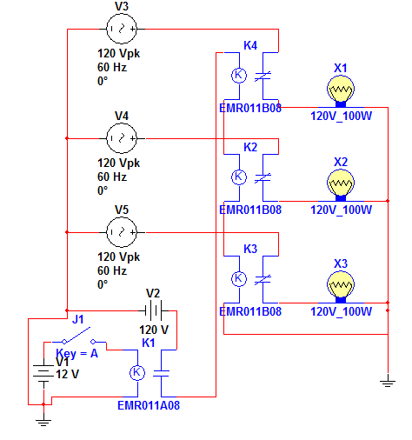
Fig.4 Simulation of the process

Cost analysis:

Estimating the cost of the whole project even the simplest thing that includes in the project can lead to succeed the project. For this solution, the estimated cost is:
1- Taking an approval and an official document from SEWA and SM 500 AED
2- Buying a contactor and a relay 220 AED
3- Hiring an expert technical support to install the contactor in the room 7000 AED.
The total cost is 7720 AED

Time analysis:

Event | Period (in week)
Taking the approval | 3
Finding a trustworthy company to install the system | 2
Selecting the suitable types of relay | 1
Designing the prototype | 2
Total weeks Eight
(Two months)
Table.1 Time resource

According to the specifications that selected from the previous report which are; cost, period, reliability, simplicity and human resource as a skill (please see appendix 2) the pros and cons of each solution are decided:

Advantages:

1- It considers as a large electromechanical switch that can handle a huge amount of current and it is very reliable.
2- It is very fast in switching operation of the contacts so it can ensure more performance.
3- Using only few mA from the main source will switch high current loads.
4- It has lower cost over the life of the product which around 200 AED only.
5- According to the loads of the room, it can disconnect the electricity from the security door also without needing of another specific relay.

Disadvantages:

1- It doesn't provide protection while the relay can. This is a critical point since the aims of these solutions is to ensure safety.
2- It is difficult to install the contactor without understanding the basic of it. Additionally, it is hard to find a suitable place to put it in the box of the main supply for the server room so an offical approval must be taken from SEWA and SM and thus will increase the time of finishing the project which is two months.
3- This solution will cut off the electricity from the whole room, even though it will ensure that the fire will not inflate but due to the uncontrolled process shutdown the racks will damaged and all data will be removed which will have a huge impact on the organization and that can be extremely costly.

3.2- Solution Two

The second solution is to control the electricity of the security door only, not the whole room. Therefore, if the smoke detector detects a certain amount of gas, it will send a signal to the siren and the gas cylinder. The signal that will pass through the siren will be sent to the relay which will be added to the circuit to disconnect the electricity on the door, as shown in figure 5. Thus, any person inside the room can exit quickly and be safe. Adding a normally close relay to the circuit will make automatic control on the security door.
Main Source / UPS
Control unit
Security door
Relay (NC)
Siren
Fig.5 block diagram of the process of solution process

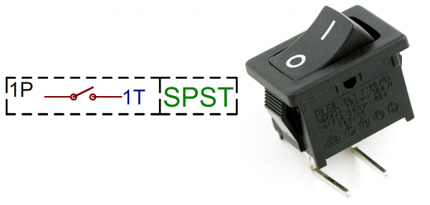
A relay is an electromagnetic switch that uses a low voltage or current to control a high voltage or current. In addition, it contains three components which are; a coil that can be a temporary magnet when low current flow through it, an armature that is movable and at least one contact. Using the normally close (NC) relay means that when the relay is not energized there will be a close contact, and vice versa. There are many types of relays depending on the number of poles, and how many circuits are needed to be influenced. Single Pole Single Throw (SPST) as shown in figure 6, is the type that is convenient to SM's situation, which will be used to control one circuit only, and because there are only one input and one output, the switch will be either ON or OFF [5].
Fig.6 SPST contact

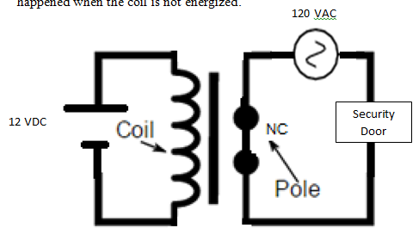
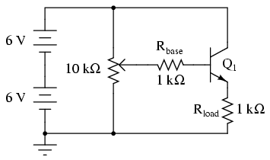
As it shown in figure 7 below, the SPST relay has two sides, one where there is a coil and the other side where there is a contact. If the coil is energized, the current that will pass through it will create a magnetic field, and since the contact is NC, the magnetic field will attract the contact and change its position to be open. The opposite happened when the coil is not energized.
Fig.7 schematic diagram of the relay

In the normal condition, the main source or the UPS will supply a 120VAC to the control unit to provide the electromagnetic lock that located on the security door, and no one can unlock it unless he disconnects the power manually by using the pushbutton or the software.
However, let's consider that there is a fire in the server room; 12VDC will apply to the relay. Therefore, the coil will be energized and the normally close (NC) contact will be open, so no current will pass through the door.
Using this solution will lead to cut off the electricity of the security door only, without having impacts on the computers, Therefore, the employees can escape from the room in safer and faster way, and nothing will affect the data.

Cost analysis:

The budget that will need to implement the project is divided into:
1- The relay itself will cost 5.59$ ≈ 20 AED.
2- The approval and the documentation will cost around 150 AED.
3- Hiring expert engineering and technical support will cost around 5000 AED.
4- Wires, cables, and other tools may cost 500 AED.
After estimating the costs, the total budget will be equal to 5671 AED

Time analysis:

Event | Period (in week)
Taking the approval | 2
Finding a trustworthy company to install the system | 1
Selecting the suitable types of relay | 1
Designing the prototype | 2
Total weeks Six
(one and half)
Table.2 Time resource

Advantages:

1- A very simple circuit that has a few components, and it designed to switch either AC or DC to the load.
2- Using a small current to control a circuit with large current.
3- Reliable.
4- Cheap
5- Will not have an impact on the racks or even the data

Disadvantages:

1- High voltages or currents apply to the relay can cause sparks.
2- Have a slow response, so switching ON and OFF may be a slowly little bit.

3.3- Solution three:

The third solution is about cutting off the electricity from the electromagnetic door only by changing the software that called (Keyscan Access Control System). Simply, if the fire occurred in the server room and someone insides there, he will be able to escape from the room if the system in the control room changed by someone else to unlock the door's situation. In other meaning, this solution generally will depend on changing the software only that they already have.
This system is mainly about controlling the entry points that include doors, elevator, and garage doors. It gives the ability to users to control the organization, provide a more secure environment and it typically works 24 hours a day, 7 days a week and 12 months a year. Additionally, the user has the ability to change the system according to what he wants it to be like [6].
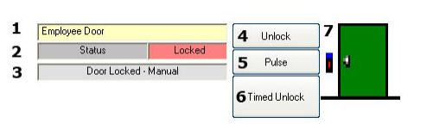
In date center room the principle of this system is to show the current state of all doors if they are locked or unlocked on the main screen by access control units in the Keyscan system. The following figure 8 reviews the seven elements that show a door's state and the instruction of changing the door's state condition.
Fig.8 Keyscan Access Control System
1. Shows the Door Name.
2. Shows the current door state which can be one of the following:
- Locked - Unlocked
3. Shows the last computer command that changed the door's state.
- Indicate to manual or auto Door lock or unlock Conditions.
4. Unlock/Lock button.
- When the door is locked, the button is labeled Unlock.
- When the door is unlocked the button is labeled Lock.
5. Freeze temporarily unlocks the door case based on the Time setting and then unlocks the door automatically.
6. Timed Unlock: allows the users to set a period to keep the door unlocked.
7. A graph representing the state of the door as follows:
- A closed door shows it is locked. - An open door shows it is unlocked.

Cost analysis:

This system is already existing in SM so no payments are required even for the future updates.

Advantages:

1- Play a role in making the organization more controlled, so it can develop a more secure environment.
2- Record a live video in the organization
3- More protection in the data center room.
4- Since it is already existing so it will not affect the specified period and cost.

Disadvantages:

1- It's manually operated, which means it needs someone to observe the situation all the time so if there is a critical condition or any exceptions it must need fast response to open the door and that is not available in the manual method.

4- Selecting final solution:

After discussing and analyzing the three solutions in details, it must be to decide one of them to be the best solution that may be implemented. One of the techniques that used to compare between these proposals to came up with the best decision by taking all the specifications into account is Decision Matrix Analysis. This method is a great technique to take decision rationally and confidently [7]. In order to use this method, the solutions must be listed as a row in a table while the specifications that discussed in the previous report (see appendix 2) must be placed in the columns of the table. Each criterion must be having a rating scale from zero (Low) to five (High). Multiply each rating scale by the weight that deserved for each factor will give the final score for each criterion, adding them will give the overall out of 100 so the highest overall means the best solution.
The specifications that are used:
- Cost (3/5); a criterion that must be considered and not exceed it. Due to the high budget that was given from SM that reach to 100,000 AED and the cheap components of each solution so this criterion not very critical.
- Period (5/5); considerable criterion, as mentioned before the solution must be done within around two months only not more than that.
- Reliability (5/5); serious criterion, since the solution must ensure safety and it consider as safety critical system that may threaten the lives of people in danger in a case of any defect in the system.
- Simplicity (4/5); important criterion that means the system must be simple that will reduce the timing response and ensure usability.
- Human resource (3/5); important criterion that has an impact on the time and the cost by taking the approval from SEWA and SM to install the contactor or the relay.

Specs  Solutions | Cost | Period | Reliability | Simplicity | Human resource | Overall
Weight | 3 | 5 | 5 | 4 | 3
Solution 1 (Contactor) | (High)  around 7720  3 × 3 = 9 | (Long)  2 months  2 × 5 = 10 | (Very low)  Since it will damage the racks and the data  0 × 5 = 0 | (High)  Easy to wire and install the contactor  4 × 4 = 16 | Technician support & the team to take approval from SEWA & SM to install the contactor  2 × 3 = 6 |  | 41
Solution 2 (Relay) | (Low)  around 5671  4 × 3 = 12 | (Short)  1 and half month  4 × 5 = 20 | (High)  It may need some maintenance each period  4 × 5 = 20 | (Very high)  Easy to wire and install the relay with only one phase  5 × 4 = 20 | The team to take approval from SM & Technician support  3 × 3 = 9 |  | 81
Solution 3 (Software) | (Very low)  already exist  5 × 3 = 15 | (Very short)  already exist  5 × 5 = 25 | (Low)  It will operate manually so there will be a delay in the response time  1 × 5 = 5 | (High)  Easy to use  4 × 4 = 16 | IT engineer  4 × 3 = 12 |  | 73
Table.3 Decision matrix analysis
After conducting the decision matrix analysis, it is clear that solution 2 (Cutting off the electricity from the door only by using a relay) is the best solution since it has the highest score (81) when compare it to the other two solutions that will be rejected. Therefore, using the relay to disconnect the power on the door only, will be implemented as a final solution as a prototype only, so the components that must be available are shown in the table below:
Table.4 Availability of the components
Component | Battery 12v | Pushbutton | Relay (SPST) | LED
Available in the lab

5- Time-based plan for researching problem solutions:

The Gantt chart will summarize and shows what are activities that will be done and when each activity will happen for the next report which is (Implementation Report Brief and Criteria). The time-based plan shown in table 4. The report will take one month to be done, so approximately from 23rd February 2017 to 23rd March 2017 as shown in figure 9.
ID | Brief description | Duration | Predecessor | Responsibility
 |  |  |  | Amina | Shaikha | Sara
A | Introduce and outlines the selected Solution. | 2 | - | R | S | S
B | Identify each component for the selected Solution. | 2 | A | S | S | R
C | Illustrate how the selected Solution operates at the circuit level. | 4 | B | S | R | S
D | Give a depth analysis and explanation about the selected Solution. | 4 | C | R | S | S
E | Using Multisim to optimize the circuit Solution. | 5 | D | S | S | R
F | Implementing and testing the selected Solution. | 6 | E | R | S | S
G | Estimation for project performance and functionality. | 2 | F | S | R | S
H | Realization the results for the solution testing. | 2 | G | S | S | R
I | Discuss the problems that happened during the solution realization. | 2 | H | R | S | S
J | Gives suggestions for improving the solution.  Table.4 Activities and responsibilities table | 1 | I | S | R | S
R: Responsible
S: Support
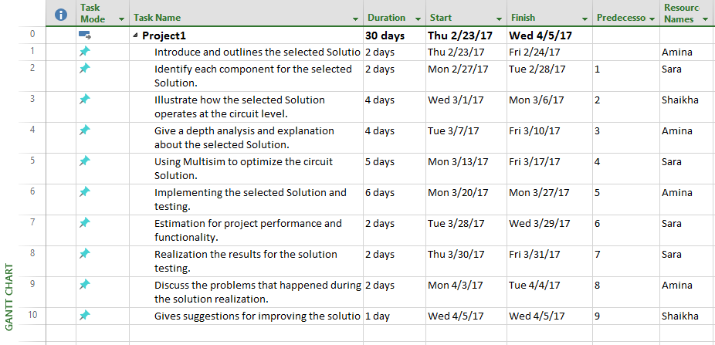

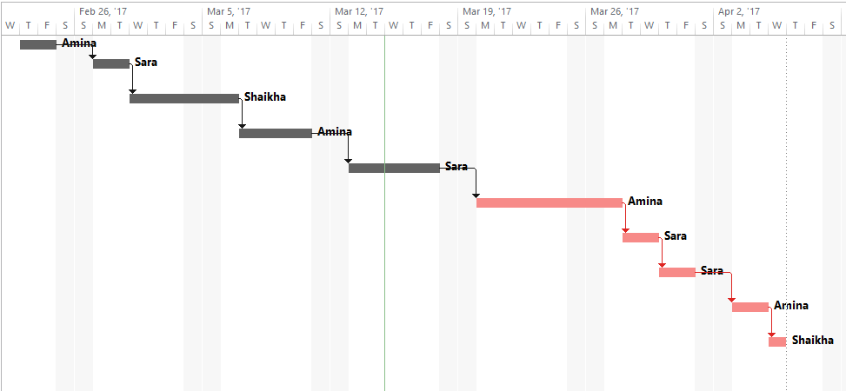
Fig.9 Gantt Chart

7- Conclusion:

To sum up, between all the three solutions, the second solution which is (Cutting off the electricity from the door only by using a relay) is the best solution to choose depending on the score that founded by applying the decision matrix analysis. The next step is to implement this solution as a prototype after studying the solution deeply to reach to a successful outcome. The system can be improved more by adding some other features such as sending a message to the civil defense and to any responsible in Sharjah municipality when the fire occurred, controlling the gas release, detection the presence of anyone in the room and eliminate the sparks that occurred by high voltages or currents.

8- References:

[1] | Jayant, "Automatic Staircase Lights using PIR Sensor and Relay," 17 August 2015. [Online]. Available: https://circuitdigest.com/electronic-circuits/automatic-room-lights-using-pir-sensor-and-relay.
[2] | A. Parashar, "Load Cut off Switch Upon Over Voltage or Under Voltage," EDGEFX KITS & SOLUTIONS , 7 June 2016. [Online]. Available: http://www.edgefxkits.com/load-cut-off-switch-upon-over-voltage-or-under-voltage.
[3] | "Molded Case Circuit Breaker (MCCB) Basic Knowledge," 21 October 2015. [Online]. Available: http://www.miniature-circuit-breaker.com/molded-case-circuit-breaker-mccb-basic-knowledge/.
[4] | P. Frank, "The Basics of Contactors," 1 December 1999. [Online]. Available: http://ecmweb.com/content/basics-contactors.
[5] | Celine, "Difference Between SPDT and DPDT," 28 July 2011. [Online]. Available: http://www.differencebetween.net/technology/difference-between-spdt-and-dpdt/#ixzz4bBxELfQn.
[6] | "Door Control Unit," Keyscan Access Control System, 2016. [Online]. Available: http://www.keyscan.ca/English/DoorControlUnits.html. [Accessed 13 March 2017].
[7] | M. Martin, "Decision Matrix: What Is and How to Use It," 19 August 2016. [Online]. Available: http://www.businessnewsdaily.com/6146-decision-matrix.html.

9- Appendix 1:
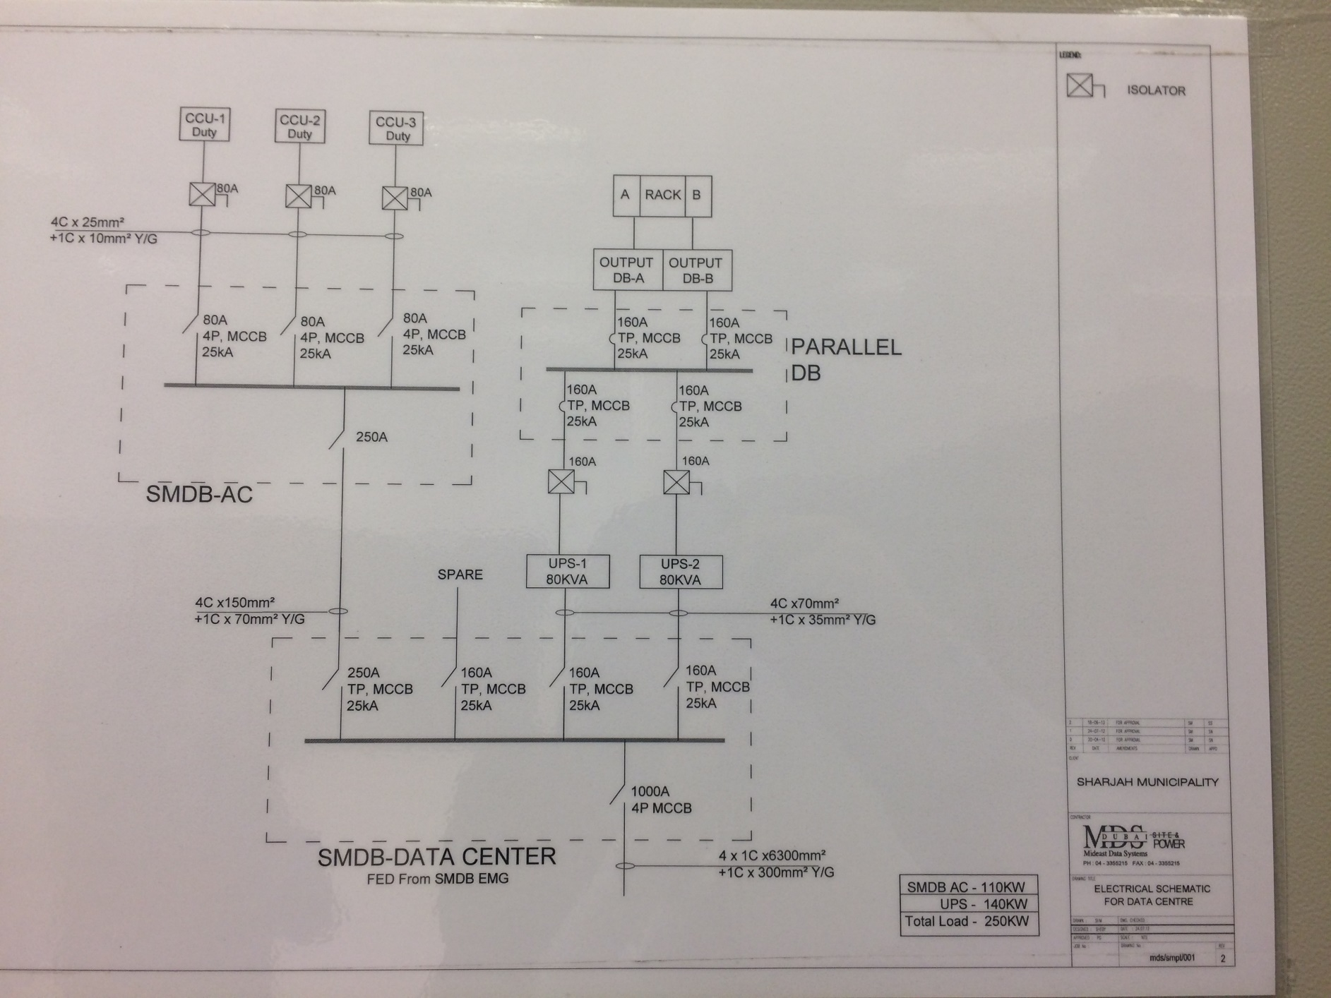

10- Appendix 2:

Specifications | Discerption
Cost | The maximum budget for SM to pay is 100,000 DHS
Period | SM wants the system to be developed by a period that does not exceed two months
Sensitivity | The solution will not include any sensor so there will be no sensitivity.
Accuracy | There is no accuracy in this system because there are no measurements.
Reliability | It will be very high to avoid any risk in the system and it will be considered as hard real-time system that does not accept any delaying in time.
Complexity | It will be simple system that is easy to be tested and installed

Skills (Human Resources)
The team (Amina, Sara & Shaikha) | Programmer | IT Technician | SM | Activity
 |  |  | R | Approve
R | S | S |  | Software
R | S | S |  | Test
S |  | S | R | Install
R: responsible
S: support

